KEYAZ CONSULTANCY
MIDTERM II EXAMINATION 2023
Age Group (4 – 5 years): MIDDLE CLASS
Learning Area 2: English

My name is ______________________________________________
School: _____________________________________________________
- Match to the belonging.


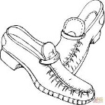

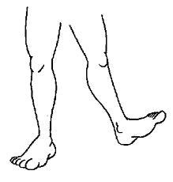
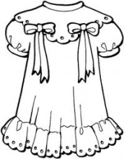


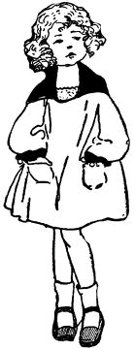

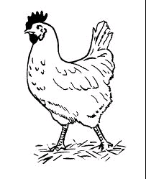


- Read and draw these people.
children teacher

gate keeper school nurse

cook cleaner

school driver

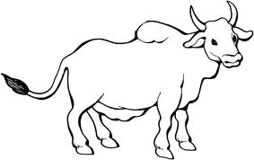
- Name these animals.
____________
goat

cat

cow

dog

rabbit
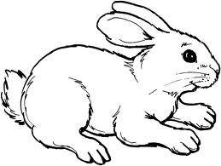
____________


____________

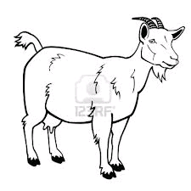
____________

____________

- Fill in the missing letters.
s ___ake z___bra r __t el___p___ant
- Match capital to small lettered words and draw.
A hut ________

B girl ________

C fish ________

E book ________
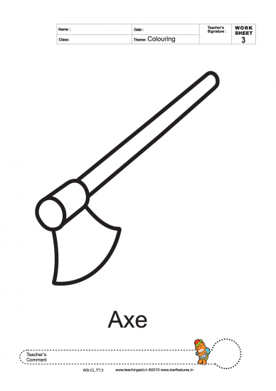
F axe _______

G egg _______

H cup ________

END

